STATE OF IOWA
BEFORE THE IOWA UTILITIES BOARD
IN RE:  Interstate Power and Light Company | DOCKET NO. SPU-2018-007

REBUTTAL TESTIMONY OF MAGDA HAVAS
Q1: Please state your name and business address.
A: My name is Magda Havas and my work address is Trent School of the Environment, Trent University, 1600 West Bank Drive, Peterborough, ON, K9J 7B8 Canada.
Q2: By whom are you presently employed and in what capacity?
A: I am currently (as I prepare this testimony) an Associate Professor at Trent University where I teach and do research. However, I will be retired as of October 1st, 2018.
Q3: What is your educational and professional background?
A: I received my B.Sc. and my Ph.D. from the University of Toronto in Biology and in Environmental Toxicology. I then did two years postdoctoral work at Cornell University in the Department of Ecology and Systematics. I returned to Canada and worked at the University of Toronto, in the Institute of Environmental Studies, as an Assistant Professor and a Natural Sciences and Engineering Resource Council (NSERC) University Research Fellow (URF) for 5 years and then went to Trent University as an Associate Professor until retiring in October 2018.
Q4: Please describe your professional experience.
A: I originally did research on the biological effects of water and air pollution with a focus on acid rain and metal toxicity. I worked with both aquatic and terrestrial ecosystems and did research on drinking water quality and human health. My work, and that of others, helped bring clean air legislation to both Canada and the United States with stricter standards for sulphur dioxide emissions.
Shortly after this, in or about 1995, I changed my focus to the study of the biological effects of non-ionizing radiation (NIR). This included extremely low frequency electromagnetic fields (ELF EMF); intermediate frequencies (IF) that involve poor power quality or “dirty electricity” as it is commonly called; radio frequency (RF) and microwave radiation (MW) radiation; as well as ground current pollution especially on farms. I work with people who have developed intolerance to electromagnetic pollution from various sources and my research is focused on finding objective ways to diagnose electro-hyper-sensitivity (EHS) as it is commonly called. I also do research on the biological effects of pulsed electromagnetic field (PEMF) therapies and the degree to which these therapies can help people with EHS.
I teach university courses and have trained graduate students at both the University of Toronto and Trent University. At Trent I taught in four courses that include lectures on electromagnetic pollution. These are Introduction to Environmental Sciences (first year course); and three senior undergraduate courses for students in their third or forth year of study – Pollution Ecology, Ecological Agriculture, and the Biological Effects of Electromagnetic Fields.
I review scientific publications for approximately 25 journals; provide scientific advice to organizations in Canada, U.S., Netherlands, Brussels, Italy, U.K., South Africa; provide expert testimony related to extremely low frequency EMFs and radio frequency radiation; and lecture around the world at scientific and medical conferences and to groups interested in the biological effects of electrosmog or the therapeutic effects of electrotherapy. I have given 366 lectures in 30 countries, 27 states in the U.S.A., and at 24 universities and almost all of these were by invitation. Refer to my CV for details (Appendix A).
I have been invited to present to various government agencies from the municipal level, through, state, federal and international levels including Mendota Heights, Minnesota; Workers Health and Safety in Ontario, Canada; Standing Committee on Environment and Sustainability, Parliament Hill, Ottawa, Canada; National Institute for Environmental Health Sciences (NIEHS) in North Carolina, U.S.; as well as the World Health Organization and Royal Academy of Medicine in Belgium. I have also been invited to brief Senate and Congressional staff in the U.S. and members of the Liberal, Conservative and Green Party in Canada on the harmful effects of electromagnetic pollution.
Q5: Have you provided testimony in prior regulatory proceedings?
A: Yes. Since 2001, I have been asked to provide expert testimony at hearings in Canada, United States, South Africa and the Philippines related to the potentially harmful effects of power frequency electromagnetic fields and radio frequency radiation. To date, I have written 28 expert testimony reports. Details available in my CV [Appendix A].
Q6: Are you sponsoring any exhibits to this direct testimony?
A: Yes. I cite a number of scientific studies and research documents and these are provided below as exhibits in the order that they are mentioned in my testimony. I also provide links to three video exhibits.
49 References Cited
Exhibit A: Hardell 2013 (cell phones and brain cancer)
Exhibit B: Cardis et al. 2012 (Interphone, cell phones and brain cancer)
Exhibit C: Sadetsky et al. 2007 (Salivary gland tumors and cell phones)
Exhibit D: Hocking et al. 1996 (antennas and cancers)
Exhibit E: Goldsmith 1997 (radar and cancers, review)
Exhibit F: Michelozzi et al. 2002 (broadcast antennas & cancer)
Exhibit G: Dode et al. 2011 (antennas and cancer mortality)
Exhibit H: Yakymenko et al. 2011 (cancers and antennas)
Exhibit I: Wirth et al. 2013. (police cancers)
Exhibit J: Chou et al. 1992 (rats microwaves)
Exhibit K: NTP 2018 (rat/mice cell phone & cancer)
Exhibit L: Falcioni et al. 2018 (rat/mice cell phone & cancer)
Exhibit M: Phillips et al. 1995 (DNA and RF)
Exhibit N: Comparing NTP and Italian studies 2018 (give link)
Exhibit O: Havas 2017 (theory & observation, difference between IR and NIR)
Exhibit P: Agarwal et al. 2008 (human sperm RF)
Exhibit Q: Adams et al. 2014 (meta study RF & human sperm)
Exhibit R: Magras et al. 1997 (mice antenna park)
Exhibit S: Kesari et al 2012 (oxidative stress rat sperm testosterone)
Exhibit T: Bevington 2018 (EHS)
Exhibit U: Dodge 1969 (in Cleary 1969) http://magdahavas.com/pick-of-the-week-6-clinical-hygienic-aspects-of-exposure-to-electromagnetic-fields/
Exhibit V: Santini et al. 2002 (EHS & cell towers)
Exhibit W: WHO 2006 (EHS meeting in 2004)
Exhibit X: Access Board US, no date provided
Exhibit Y: Glaser 1972 (over 2000 references on the biological effects of microwave radiation) http://magdahavas.com/pick-of-the-week-1-more-than-2000-documents-prior-to-1972-on-bioeffects-of-radio-frequency-radiation/
Exhibit Z: Steneck et al. 1980 (FCC guidelines, history) http://magdahavas.com/pick-of-the-week-2-origins-of-1966-u-s-safety-standards-for-microwave-radiation/
Exhibit AA: International Expert Appeals, list from around the world; http://magdahavas.com/international-experts-perspective-on-the-health-effects-of-electromagnetic-fields-emf-and-electromagnetic-radiation-emr/
Exhibit BB: Blank et al. 2015 (International EMF scientist appeal)
Exhibit CC: Ontario Hydro 1996 (power quality)
Exhibit DD: Havas et al. 2010 (HRV & microwaves)
Exhibit EE: Havas 2013 (blood, heart, ANS)
Exhibit FF: Cleary 1969 (Symposium on the biological effects and health implications of microwave radiation. http://magdahavas.com/pick-of-the-week-22-a-very-important-symposium/
Exhibit GG: Havas 2008 (DE & diabetes)
Exhibit HH: Havas 2016 (diabetes)
Exhibit II: Havas 2006 (DE & MS)
Exhibit JJ: Havas and Olstad 2008 (DE schools)
Exhibit KK: Milham and Morgan 2008 (DE cancer)
Exhibit LL: IARC 2011 web (RF Class 2B carcinogen)
Exhibit MM: AAEM 2011
Exhibit NN: Huss et al. 2007 (funding & results)
Exhibit OO: Eskander et al. 2011(hormones cell towers)
Exhibit PP: BioInitiative Report 2007; www.bioinitiativereport.com
Exhibit QQ: Hankin 2002 (letter, FCC guidelines are thermal)
Exhibit RR: RFR Guidelines (national and international RF guidelines)
Exhibit SS: Royal Society of Canada 1999 (mechanisms RF)
Exhibit TT: Pall 2013 (mechanisms RF)
Exhibit UU: West 2013 (cell phones and breast cancer)
Exhibit VV: Health Canada Safety Code 6, 1999 (page 11 on EHS)
Exhibit WW: Johannson 2006 (EHS in Sweden)
Three Video Exhibits:
Exhibit XX: http://magdahavas.com/multiple-sclerosis-and-dirty-electricity/ (MS symptoms and dirty electricity)
Exhibit YY: http://magdahavas.com/smart-meter-kills-plant/ (smart meter radiating)
Exhibit ZZ: http://magdahavas.com/iarc-declares-rf-from-cell-phones-and-cell-towers-dangerous/ at 3:11 in video
Q7: What is the nature of your testimony?
A: In this affidavit I provide evidence regarding the harmful effects of radio frequency radiation (RFR) that includes intermediate frequencies (IF) and microwave radiation (MWR) at levels well below existing guidelines and comment on the testimony of Dr. Peter Valberg.
Based on scientific research, RFR and MWR have adverse effects on the body that can be classified into three categories: cancers, reproductive problems, and symptoms of electrohypersensitivity (EHS).
Q8: Can you summarize the effects of RF radiation (RFR) on cancer?
A: Yes. RFR has been associated with cancers in people who use cell phones for more than 10 years. The tumors occur primarily on the same side of the head exposed to the cell phone (ipsilateral tumors) and they include astrocytomas, gliomas, meningiomas, acoustic neuromas, and salivary gland tumors [Exhibits A–C].
People who live near cell phone base stations, radio and TV broadcast antennas and radar installation have a greater risk of developing and dying from cancers than people who live further away [Exhibits D–H]. Many of these studies show an increase in leukemias especially among children.
Furthermore, those who are occupationally exposed have a greater risk of developing different types of cancers [Exhibit I]. These are all epidemiological studies and such studies show an association between exposure (or a surrogate of exposure) and an increased risk of cancer that increases with duration of exposure.
We also have at least three well-controlled, animal studies documenting that microwave radiation causes cancer [Exhibits J – L] and damages DNA in rodents [Exhibits M].
A study conducted by the U.S. Air Force at a cost of $4.5 million dollars exposed rats to pulsed 2.45 GHz microwave radiation (same frequency used in Wi-Fi) [Exhibit J]. Two hundred male rats were assigned in equal numbers to either sham exposure (controls) or radiation exposure at an average SAR (specific absorption rate) between 0.15 and 0.4 W/kg (depending on size of animal). Exposure was for 21.5 h/day and began at 8 weeks and lasted for 25 months. Animals were examined when they died or at the end of the experiment for those who survived (truncated survival). Authors reported a 100% increase in metastatic tumors and a 260% increase in primary tumors for the rats exposed to the MW radiation compared with the sham-exposed rats [Exhibit J, page 488, Table 2]. The authors state that, “A statistically significant increase of primary malignancies in exposed rats vs. incidence in controls is a provocative finding, but the biological significance of this effect in the absence of truncated longevity is conjectural.” [Exhibit J, page 470]. What this means is that it is not possible to know if survival times were affected as surviving rats were euthanized at 25 months.
The more recent NTP study (Exhibit K), a multi-year, multi-million dollar study conducted by the National Toxicology Program reported two types of cancers in male rats exposed to cell phone radiation that are also found in humans (malignant gliomas in the brain and schwannomas of the heart). Malignant gliomas have also been reported in epidemiological studies with people who use cell phones [Exhibit A and B] and schwannomas are the cells involved in acoustic neuromas, a benign tumor that grows on the nerve responsible for hearing and balance in humans [Exhibit A].
The Italian study [Exhibit L] was published shortly after the NTP study and reported tumors of the brain and heart as well, similar to the NTP study, but at much lower SAR levels (specific absorption rate). See comparison of these two studies [Exhibit N]. These results indicate a cause-effect relationship and support the human epidemiological studies related to tumors of the head.
RF and MW radiation are classified as non-ionizing radiation (NIR). Considerable evidence exists that NIR increases free radicals by interfering with the neutralization of reactive oxygen species (ROS) [Exhibits H and O]. ROS are known to cause cancer and other adverse biological effects.
Q9: Can you summarize the effects of non-ionizing radiation on reproduction?
A. Yes. Considerable evidence shows that NIR damages sperm. At least twenty studies show abnormalities in sperm, which have clear implications for male infertility. At least five studies show DNA damage, which could be teratogenic (affecting the development of the embryo or fetus) and multi-generational.
Exhibit P documents reduced sperm count, reduced sperm motility, reduced sperm viability and increased abnormal sperm morphology among men who use cell phones. The longer they use cell phones each day the greater the damage to sperm (Figure 1; Exhibit P based on Table 1 page 215). This study shows a dose-response relationship and suggests causation.
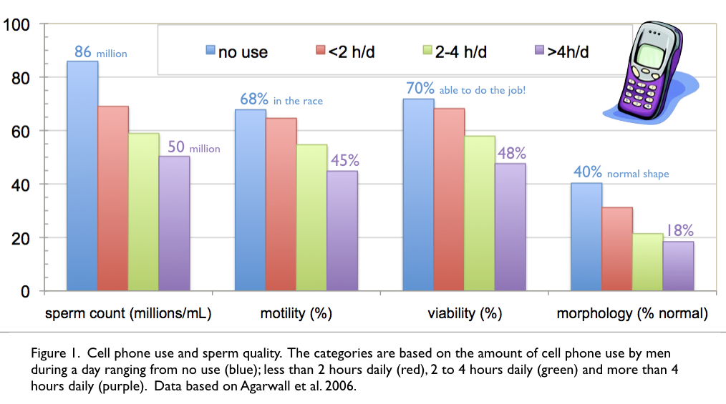
Adams et al. [2014] did a meta-analysis based on ten studies regarding the effects of mobile phones on sperm quality and presented the following conclusions in their abstract [Exhibit Q, page 106]:
We conclude that pooled results from in vitro and in vivo studies suggest that mobile phone exposure negatively affects sperm quality. Further study is required to determine the full clinical implications for both sub-fertile men and the general population.
Studies with mice exposed to radiation at an antenna park resulted in irreversible infertility within 5 generations of exposure [Exhibit R]. The highest exposure in this study was 1.053 microW/cm², which is 0.2% the FCC guideline of 600 microW/cm² [page 455].
In one laboratory study [Exhibit S] reactive oxygen species (ROS) were shown to reduce testosterone in rats exposed to mobile phone radiation. Lower levels of testosterone are likely to adversely affect sperm production. Note testosterone levels were also lower for people who live within 500 m of cell phone antennas [Exhibit OO].
We have scientific evidence from both human and animal studies documenting damage to sperm, impaired reproduction and altered hormonal levels. There is nothing more powerful in science as when studies, conducted in different ways, in different countries, with various organisms including humans, by many researchers point in the same direction and support the concept that RF and MW radiation harms sperm, reduces testosterone levels and adversely affects reproduction.
Q10: What is electrohypersensitivity (EHS)?
A: Electrohypersensitivity (EHS) refers to a group of symptoms that include poor sleep; chronic fatigue; cognitive dysfunction including brain fog, difficulty concentrating and poor short-term memory; mood disorders including depression and anxiety; chronic pain including headaches and/or migraines; dizziness; nausea; tinnitus; heart palpitations; abnormal blood sugar; skin problems; asthma; among others [Exhibit T, page 6]. These symptoms were originally called neurasthenia or asthenic syndrome and later microwave syndrome or radio wave sickness. The scientific community has recognized these symptoms since the early to mid 1900s [Exhibit U]. Dodge states that electromagnetic radiation affects the central nervous system, autonomic nervous system, neurohumoral systems, endocrine glands and function, eye and ocular functions, blood and hemapoietic system and miscellaneous organs in humans [Exhibit U, page 141]. He provides symptoms [Exhibit U, page 142] that are similar to what we now call EHS.
Q11: What is the scientific evidence for EHS?
A: Studies for EHS include epidemiological studies of people who live near cell phone antennas or are otherwise exposed to this radiation under normal working/living conditions and studies where subjects (human or animal) are exposed to conditions that are experimentally altered (either increased or decreased) and their reactions are documented.
Q12: Can you give us an example of an epidemiological study that tested the effect of MW radiation?
A: Yes. Santini et al. 2002 [Exhibit V] reported the symptoms of people who live at different distances from cell phone antennas. This is called an epidemiological study. People who live closest to the antennas (within 10 m, red columns) have the highest incidence of EHS symptoms and those furthest away (beyond 300 m, black columns) the lowest incidence. (Figure 2, based on Exhibit V, page 3, Table 1]. Similar results have been reported in other countries.
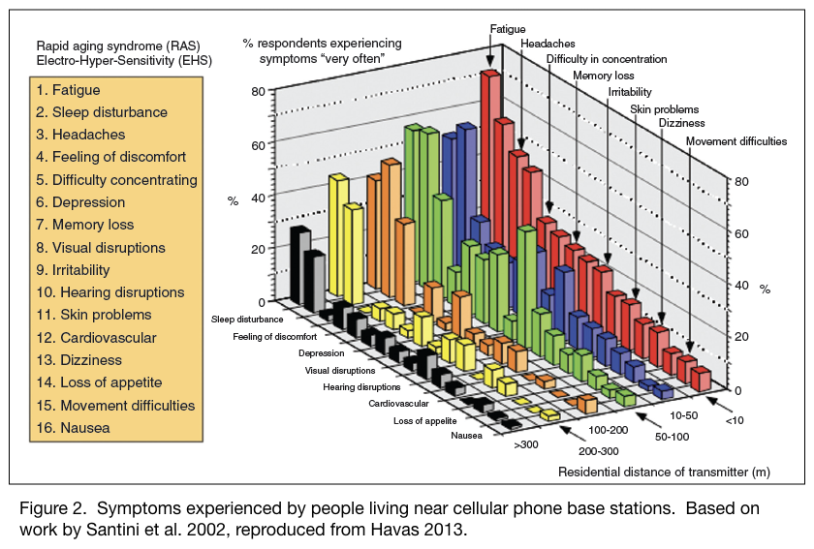
Q13: Can you give us an example of an experiment that tested the effect of MW radiation on EHS?
A: An example of an experiment is one we did testing the effect of MW radiation from a mobile phone base station on heart rate variability (HRV) [Exhibit DD]. We did a double-blind, placebo controlled study with 25 human volunteers in Colorado and found that some of them developed either tachycardia (rapid heart rate) or arrhythmia (irregular heart rate) when exposed to 2.4 GHz from a cordless phone base station placed near their body. Their body went into a “fight, flight or faint” response as indicated by their autonomic nervous system (ANS) with an up regulation of their sympathetic tone and a down regulation of their parasympathetic tone. When this happens the person believes they are having either an anxiety attack or a heart attack. The former is a more accurate description of what is happening. When the cordless phone base station was disconnected from the electrical outlet, their heart rate and their autonomic nervous system returned to normal. Note that some of the early research also indicates that MWs affect the autonomic nervous system [Exhibit Y and Z].
In a Symposium Proceedings on the Biological Effects and Health Implications of Microwave Radiation [Exhibit FF, page 94], researchers recommended that,
In the interest of occupational hygiene . . . cardiovascular abnormalities be used as screening criteria to exclude people from occupations involving radio-frequency exposures.
Perhaps this could be done for students and teachers at schools where Wi-Fi is installed and for people living in homes with smart meters.
There is evidence that MWs affect the heart, the ANS, as well as the blood [Exhibit EE]. My own blood becomes more viscous when I am exposed to MW radiation for 10 minutes and this can be observed under a microscope (Plate 1). Symptoms of this can involve cold, numbness or tingling in fingers and toes; dizziness and nausea; with more severe symptoms leading to blood clots, strokes, or heart attacks.
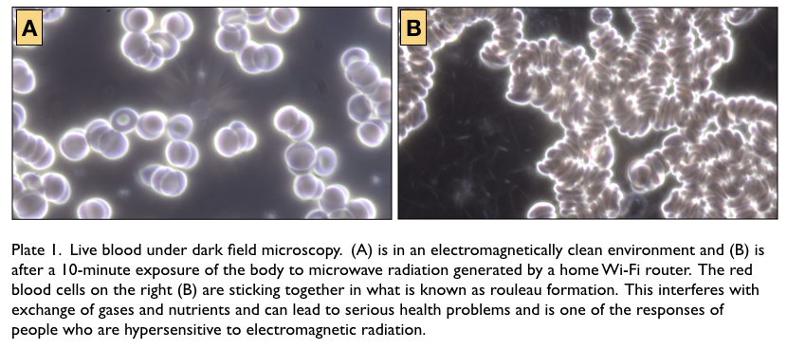
Q14: Do any governing bodies recognize EHS?
A: Yes. The WHO recognizes EHS but would prefer to call it idiopathic environmental intolerance attributable to electromagnetic fields. At their International Seminar in Prague, the WHO made the following statement about EMF hypersensitivity [Exhibit W, pages V, 7]:
. . . a phenomenon where individuals experience adverse health effects while using or being in the vicinity of devices emanating electric, magnetic, or electromagnetic fields (EMFs) … Whatever its cause, EHS is a real and sometimes a debilitating problem for the affected persons … Their exposures are generally several orders of magnitude under the limits in internationally accepted standards.
What this means is that the international standards (as well as those in the U.S. since they are the same) do not protect people who have EHS.
Health Canada in their Safety Code 6 report [Exhibit VV, page 11] acknowledges that,
Certain members of the general public may be more susceptible to harm from RF and microwave exposure.
The Swedish government has recognized EHS as an impairment that is caused by the environment [Exhibit WW]. They provide low EMF/ER rooms in hospitals for people with EHS as well as cottages with low exposure where people can go for several weeks to recover.
The U.S. government (Architectural and Transportation Barriers Compliance Board) has recognized EHS as a disability since 2002 [Exhibit X].
The Board recognizes that multiple chemical sensitivities and electromagnetic sensitivities may be considered disabilities under the ADA [American Disabilities Act] if they so severely impair the neurological, respiratory or other functions of an individual that it substantially limits one or more of the individual’s major life activities. The Board plans to closely examine the needs of this population, and undertake activities that address accessibility issues for these individuals.
However, despite this recognition, few accommodations have been made for those with EHS in the U.S.
Q15: Do the studies you mention on cancer, reproductive effects and EHS constitute a substantial body of valid scientific evidence?
A: Yes. There are now tens of thousands of peer-reviewed documents on these effects, and what few people realize is that the effects mentioned above have been known for decades [Exhibit Y]. Dr. Zory R. Glaser, former U.S. Navy Researcher and the Navy’s key person responsible for microwave health, NIOSH Manger and Executive Secretary to the U.S. FDA, gave me his entire collection of declassified research articles, letters, and notes (more than 6000 documents) when he retired. Some of those articles are on my website: http://magdahavas.com/category/from-zorys-archive/ .
As early as 1972, Dr. Glaser published a paper that listed more than 2000 references documenting the adverse effects of microwave radiation. The Glaser document counters the statements that “credible” research does not exist showing non-thermal effects. The research that I summarized is newer research and just a small sample of what is available in the scientific literature. The statement that there are no thermal effects is a false statement promoted by those who are either unaware of the scientific literature or unwilling to admit this radiation–at levels to which we are currently exposed–can be harmful. Good science that most people would consider “credible” does exist; it has been around for decades, but it has been largely ignored by many.
The above-mentioned effects (cancers, reproductive problems and EHS) are documented at levels below current U.S. guidelines, which were designed only to prevent a heating effect in healthy adult males and, as such, have not been updated.
Q16: Have the FCC guidelines changed since they were first introduced?
A: Yes. They have been significantly reduced in stages from 100,000 to 1,000 microW/cm² but are still 100 times higher than the Russian guidelines [Exhibit RR].
Steneck et al. (1980) [Exhibit Z] reviewed the origins of the U.S. safety standards for microwave radiation. The significance of this research is provided on my website [http://magdahavas.com/pick-of-the-week-2-origins-of-1966-u-s-safety-standards-for-microwave-radiation/ and is partly reproduced below. Based on published and unpublished literature as well as interviews and questionnaires, the authors of this report pieced together the process that led to the 1980 standard of 10 milliW/cm² (which is the same as 10,000 microW/cm²) designed to protect military and occupationally exposed personnel from microwave radiation. The original recommended standard, established in 1953, was 100 milliW/cm² (which is the same as 100,000 microW/cm²) and was based on a quick-and-dirty calculation that was grossly flawed and was almost immediately revised downward to 10 milliW/cm² (10,000 microW/cm²). This calculation was based on the ability of a 70-kg man to dissipate heat. The 100 milliW/cm² was obviously too high so a safety factor of 10 was introduced to reduce it to 10 milliW/cm² (10,000 microW/cm2). In the 1990s, this value was deemed too high and was further reduced to 1,000 microW/cm², which is the current guideline.
If a particular level of exposure is deemed harmful, then often a “safety factor” is introduced to provide a margin of safety. Initially the disagreement about the appropriate safety factor ranged from a safety factor of 10 recommended by the US military to 100 suggested by General Electric to 1,000 suggested by Bell Telephone Laboratories. The military prevailed. Evidence for non-thermal effects was discounted. Had the Bell Laboratories’ guideline prevailed current guideline would be 100 times lower and closer to those in Russia.
What few people realize is that emphasis was to protect military operations and secondarily to protect military personnel. Protection of the general public was barely discussed and no public standards were set because microwaves were viewed as radar and radar was limited to military and industrial exposure.
Q17: How do the studies you refer to above compare to RF emissions from smart meters?
A: Smart meters generate two types of electromagnetic frequencies and both of these are classified as RF and both have biological effects. The one I have focused on so far in this testimony and the one most people are familiar with are microwaves (MW) at 900 MHz, in this particular case. The other exposure consists of intermediate frequencies (IF) in the kHz range and few people realize that smart meters produce these frequencies.
Q18: How do microwaves differ from intermediate frequencies?
A: Both microwaves and intermediate frequencies are classified as radio frequencies although they are at different parts of the RF spectrum. Microwaves range from 300 MHz to 300 GHz and intermediate frequencies are primarily in the kHz range.
While MWs travel through the air and can penetrate buildings, IFs flow along electrical wires in the home and can radiate from these wires. Another term for these IFs is “dirty electricity,” which contributes to poor power quality. Dirty electricity consists of high voltage frequencies transients (HVFT) that can be measured using an oscilloscope. HVFTs contribute to electromagnetic interferences (EMI) that can damage sensitive electronic equipment. Similarly these frequencies can interfere with the electrical circuitry in the body. Ontario Hydro [1996] [Exhibit CC] has a 130-page reference guide, entitled Power Quality, dealing with remediating poor power quality.
The 1996 FCC guidelines included for the first time specific restrictions on currents induced in the human body by RF fields. These restrictions apply to both "induced" currents and "contact" currents related to shock and burn hazards for frequencies between 3 kHz and 100 MHz (page 50, https://transition.fcc.gov/Bureaus/Engineering_Technology/Orders/1996/fcc96326.pdf ) .
Q19: What scientific evidence is there that IF are biologically harmful?
A: Milham and Morgan (2008) published on the association between dirty electricity and cancers and we’ve done research with diabetics, people with neurological disorders like multiple sclerosis, and dirty electricity in schools.
Q20: Can you tell us about dirty electricity and cancer?
A: Milham and Morgan (2008) [Exhibit KK] reported an increased risk of cancers among teachers exposed to dirty electricity in their classroom. The greater their exposure to dirty electricity, based on intensity and duration of exposure at the school, the greater their risk of developing cancer. IARC classified frequencies below and above IF as being “possibly” carcinogenic and this is the first study documenting cancers at these intermediate frequencies.
Q21: Can you tell us about dirty electricity and diabetes?
A: We have worked with pre-diabetics and diabetics (type 1 and type 2) who are also electrically hypersensitive and found that these individuals have great difficulty regulating their blood sugar in an environment where they are exposed to poor power quality [Exhibits GG and HH]. When levels of dirty electricity are high their blood sugar increases rapidly (within a matter of 20 minutes) and when they move to an electromagnetically clean environment their blood sugar drops just as rapidly. Often these individuals require more medication in an environment with dirty electricity. Being unable to control blood sugar can be life-threatening and can contribute to chronic illness including but not limited to organ damage, poor circulation, blindness and neuropathy.
According to the Center for Disease Control (CDC), 30 million people in the U.S. (9.4% of the American population) had diabetes in 2015. With so many diabetics and pre-diabetics in the U.S. it is unwise to increase their exposure to poor power quality if this can be avoided. Providing them with a meter that measures electricity consumption (also water and gas consumption) but one that does not generate dirty power is what is needed. Exacerbating symptoms of diabetes, for those diabetics and pre-diabetics who are also EHS, is likely to be quite costly from a human health perspective and will place greater pressure on the health care system in this country.
Q22: Can you tell us about dirty electricity and multiple sclerosis?
A: We have done studies with people who have Multiple Sclerosis (MS) and found that their symptoms improve when the dirty electricity in their home is reduced [Exhibit II]. We have video evidence of tremors and ability to walk before and after remediation (see http://magdahavas.com/multiple-sclerosis-and-dirty-electricity/ ] (Exhibit XX). We also have evidence that living in a home for 7 years with reduced levels of dirty electricity reduces sclerosis in the brain as measured by MRI scans and hence this cannot be considered a placebo effect. In addition to improved physical symptoms like balance and tremors, we also noticed an improvement in cognitive activity.
Q23: Can you tell us about dirty electricity in schools?
When we reduced the levels of dirty electricity in schools, we found that teacher health and student behavior improved during remediation [Exhibit JJ]. The teacher symptoms that recovered are those associated with EHS. The student behavior that improved resembles symptoms of attention deficit hyperactivity disorder (ADHD).
If reducing dirty electricity in a home or school improves the health and wellness of some individuals, one may expect that increasing the levels of dirty electricity may have the opposite effect. Many people have told me that their health problems began shortly after a smart meter was installed on the side of their home.
One aspect that has not been mentioned is that “smart” appliances are being developed to “talk” to smart meters. This could increase the microwave radiation in the home considerably if the communication occurs frequently between the smart meter and the various appliances. This will add yet another layer of electromagnetic pollution in the home environment that should be a safe haven for those who are sensitive and for those who do not want continuous exposure. In a detached home, we measured the MW radiation coming from a smart refrigerator even though it wasn’t yet communicating with the smart meter. The radiation came in bursts every few seconds and totally disappeared when we unplugged the refrigerator. The refrigerator was on the first floor and we could detect radiation from the refrigerator on the second floor of this dwelling.
Many companies that distribute smart meters make the claim that smart meters radiate only for a few second each day so we have nothing to be concerned about. However, measurements of smart meters provides contrary evidence as shown in this video:http://magdahavas.com/smart-meter-kills-plant/ . [Exhibit YY].
Each time a smart meter sends out a blast of radiation, it is like an alarm bugle to the cells in the human body and contributes to cellular stress as indicated by stress protein production and these blast happen day and night, week after week, and year after year.
Q24: Have you read the testimony of Dr. Peter A. Valberg?
A: Yes, I have.
Q25: What are you comments about his testimony?
A: First, I am surprised about the information provided by Dr. Valberg in his testimony, as it is grossly misleading and incorrect in a number of places.
Q26: Would you care to elaborate?
A: Yes. On page 1, Dr. Valberg states the following: “No public health agency has identified the RF from any utility’s smart meters as hazardous to health.”
While this statement may be “factually correct” it is misleading to the extent that it implies that smart meter radiation is safe. Smart meters have not been around long enough for any long-term studies. However, we do know that RF radiation (which is one type of radiation emitted by smart meters) is potentially harmful as identified by the International Agency for Research on Cancer [Exhibit LL] and by various studies showing an increased risk of cancers with cell phone use and exposure to cell phone base stations, broadcast antennas and radar antennas and various laboratory studies with animals exposed to mobile phone radiation and Wi-Fi radiation, as mentioned above in my testimony. There are also problems with reproduction and adverse health effects for people who are highly sensitive to this type of radiation.
Dr. Jonathan M Samet, MD, University of Southern California, who was the Chair of the international group of scientists responsible for the Class 2B (“possibly” carcinogenic) RF designation at IARC, stated the following at a press conference: [http://magdahavas.com/iarc-declares-rf-from-cell-phones-and-cell-towers-dangerous/ at 3:11 in video] [Exhibit ZZ]:
The designation of Group 2B is radio frequency electromagnetic fields and is unspecified as to source. So the Group 2B classification would have broad applicability to sources with this type of emissions.
In other words, radio frequency radiation has been associated with cancers and it is virtually irrelevant if these frequencies are generated by smart meters, cell phones, Wi-Fi or some other source of MW/RF radiation. If someone is allergic to peanuts it doesn’t matter if the peanut is in a chocolate bar or in a sandwich. A more accurate statement regarding smart meters would be as follows, “Scientific research has identified that RFR is hazardous to human health at levels well below international guidelines and since smart meters emit RFR they are also potentially hazardous to human health.”
Q27: Do you agree with Dr. Valberg’s statement (page 1) that: “… a large number of scientific groups have reviewed research findings on potential health effects of RF waves without finding credible evidence that RF intensities below protective guidelines levels pose a threat to health.”
A: This I consider a misleading statement as an equally large group of scientists and medical doctors are asking that the guidelines currently available in the United States and those recommended by ICNIRP be reduced because intensities well below guidelines are making people ill. Since 1997, EMF and RF experts have submitted at least 35 appeals stating that levels below existing guidelines are making people ill and that governments need to develop non-thermal guidelines that truly protect the health of the pubic and especially of children and pregnant women. http://magdahavas.com/international-experts-perspective-on-the-health-effects-of-electromagnetic-fields-emf-and-electromagnetic-radiation-emr/ [Exhibit AA]
Of particular note is the International EMF Scientist Appeal, which was signed by more than 200 scientists and doctors who publish in this field from more than 40 countries [Exhibit BB, page 3]. That Appeal stated (Items iii, iv and v are particularly relevant to smart meters):
Collectively we requested that:
i. children and pregnant women be protected;
ii. guidelines and regulatory standards be strengthened;
iii. manufacturers be encouraged to develop safer technology;
iv. utilities responsible for the generation, transmission, distribution, and monitoring of electricity maintain adequate power quality and ensure proper electrical wiring to minimize harmful ground current;
v. the public be fully informed about the potential health risks from electromagnetic energy and taught harm reduction strategies;
vi. medical professionals be educated about the biological effects of electromagnetic energy and be provided training on treatment of patients with electromagnetic sensitivity;
vii. governments fund training and research on electromagnetic fields and health that is independent of industry and mandate industry cooperation with researchers;
viii. media disclose experts’ financial relationships with industry when citing their opinions regarding health and safety aspects of EMF-emitting technologies; and
ix. white-zones (radiation-free areas) be established.
The American Academy of Environmental Medicine [Exhibit MM, page 2] called for the following regarding smart meters:
• An immediate moratorium on “smart meter” installation until these serious public health issues are resolved. Continuing with their installation would be extremely irresponsible.
• Modify the revised proposed decision to include hearings on health impact in the second proceedings, along with cost evaluation and community wide opt‐out.
• Provide immediate relief to those requesting it and restore the analog meters.
We have also had notifications from the WHO, FCC, Health Canada, American Academy of Paediatrics (60,000 Paediatricians and Paediatric Surgeons), the American Academy of Environmental Medicine and various teachers unions that children are more vulnerable than adults to RF radiation and should limit their exposure.
In the United States, EHS has been recognized since 2002 and is considered a disability although few accommodations have been made for individuals suffering from electromagnetic sensitivities [Exhibit X]. Smart meters are non-compliant with the American Disabilities Act.
Q28: Is the scientific community conflicted about whether smart meters and cell phones are safe?
A: A non-expert may conclude that the scientific community is conflicted when it comes to determining whether or not existing guidelines are safe. However, an examination of the source of funding and the results of studies indicates that research funded by industry have a preponderance of “no effects”, while those independently funded are showing a preponderance of significant adverse effects (Figure 3) [Exhibit NN, based onTable 2, page 3].
In the figure below, only 33% of the studies funded by industry reported a statistically significant adverse effect of mobile phone use, whereas those studies with mixed funding or non-industry funding showing adverse effects of cell phone use ranged from 71% to 82%. Conversely, 88% of the authors funded by industry reported “no effects” of cell phone use, whereas this was much reduced (23% to 46%) in the studies otherwise funded. These results are statistically significant and suggest an inherent bias for the industry-funded studies.
This potential bias in scientific publications is becoming so extreme that journals are requiring information on funding sources and disclaimers of conflict of interest.
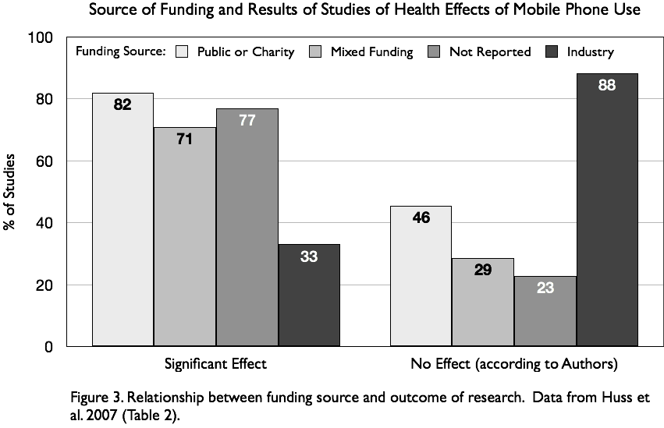
Q29: Apart from the studies and statements you referred to previously, do you have other objections to Dr. Valberg’s assertions about there being a lack of “credible” evidence of harm from RF radiation?
A: Yes. Dr. Valberg uses the term “credibility evidence.” Credible according to what criteria and according to whom? The term “credible” is not a scientific term but one used by agencies and individuals attempting to downplay adverse effects. Credible is a value-laden term and one that most scientists would avoid using. Either the science is good or bad. If it is “bad” and does not follow the scientific method or has some inherent flaws it is not considered science.
Q30: Do you agree with the statement (page 8) that, “… we have no indication that our increasing use of RF over time has adversely affected human health.”
A: No. Quite the contrary. The evidence that RF radiation is harmful to human health is overwhelming. In addition to cancer, RF radiation damages human sperm, interferes with reproduction of mice exposed to an antenna park (at levels well below FCC guidelines), and reduces testosterone levels in laboratory rats. There is an association with people living near (within 500 m from) cellular antennas and a decrease in hormones (testosterone, plasma ACTH, serum cortisol, T3, T4 and progesterone), which gets worse with duration of exposure from 1 to 3 to 5 years [Exhibit OO]. We also have evidence of an increase in symptoms of EHS for people living within 300 m from cell towers [Exhibit V]. Furthermore, we have thousands of studies dating back to 1972 [Exhibit Y] showing adverse biological and health effects of microwave radiation. We also have recent reviews with thousands of additional documents referenced for electrohypersensitivity [Exhibit T] and for a variety of other health effects [Exhibit PP] available at www.bioinitiative.com. These documents cannot all be ignored. What must be kept in mind is that a study that reports “no effect” does not negate a study that finds an effect. If all of the studies reporting adverse effects were due entirely to chance, then we should have an equal number of studies showing beneficial effects of this radiation (also due to chance). Very few of these studies exist.
Q31: Dr. Valberg (page 9) states that “The averaged power density of the Sensus meter at one half-foot distance is about 50,000-fold below the FCC maximum permissible exposure (MPE) of the general public.” Do you have any comments regarding this statement?
A: Yes. The information provided on page 9 makes no sense. The FCC guideline for 900 MHz is 600 microWatts/cm². The values Dr. Valberg states for the power density at one-half foot (20 cm) distance from the Sensus meter is 0.254 milliWatts/cm² (which is the same as 254 microWatts/cm², if we are to use the same units). This value (254/600 microWatts/cm²) is 42% of the FCC guidelines and is not 50,000 times lower!
Furthermore, the measurements of smart meter power density referred to takes into account the duty cycle and provides an “average” value rather than the maximum exposure. Indeed, Dr. Valberg states “averaged power density” in his statement on page 9 and refers to the duty cycle on page 12 of his testimony. A reliance on the “average” power density is one way of downplaying exposure intensity. An “average” value is how the utility refers to exposure from smart meters. Indeed, the FCC guidelines are based on values averaged over a 30-minute period.
Biological organisms respond to “extremes” not averages. For example, tomato plants are frost-intolerant. Consequently a tomato plant will die should the temperature drop below freezing for 1 hour during the night even though the “average” temperature during the night or during a 24-hour period may be well above freezing. Similarly, if you accidentally scald your hand in boiling water and immediately follow with a cold-water rinse, you will still experience damage despite the average temperature of the water being well below the boiling point.
So a smart meter with a duty cycle of 10% means it is “on” 10% of the time although the reading is “averaged” over the entire time interval and hence the average reading is much lower than the pulse during transmission. The lower the duty cycle the lower the average reading and the more misleading.
And finally, in the footnote on page 9, Dr. Valberg uses the terms “general public safe exposure level” when referring to the FCC guidelines. These guidelines simply ensure that there is no heating of tissue and they do not take into account any other biological effect. Dr. Valberg admits as much in his testimony on page 13, lines 15 to 17, where he states that “ there are no regulations for non-thermal effects because these remain speculative . . .”. What the public is concerned about are the non-thermal biological effects, and for agencies to have regulations that ignore biological effects is certainly not in the public interest.
Q 32: Did you read the Response of Interstate Power and Light Company to KATHY J. MATARA Interrogatory No. 25, Dated September 14, 2018?
A: Yes I did.
Q33: Would you care to comment on the power density values presented in that document and how they relate to some of the studies you mentioned?
A: Yes. It was useful to have the maximum and average values presented for Stratus smart meters. I will compare Figure 1 on pages 5 with data on effects in Exhibit RR (Figure 5).
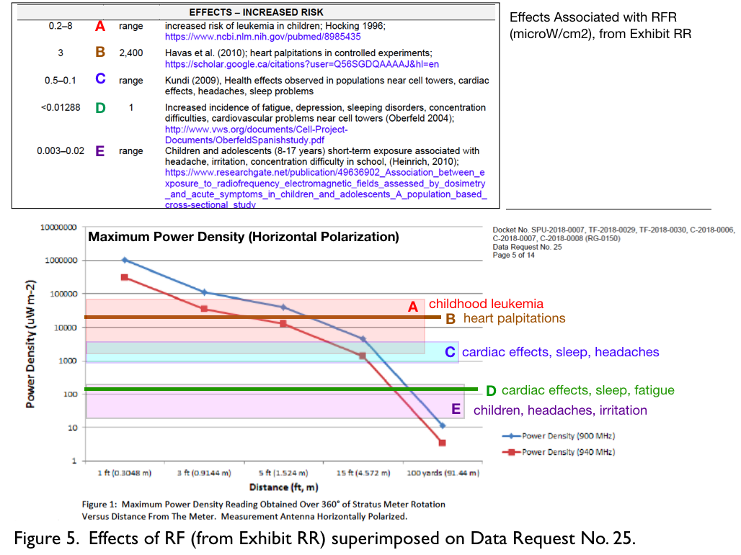
A child sleeping within 15 feet of a Sensus smart meter would be exposed to levels associated with childhood leukemia as shown in Figure 5 above (A). Adults with EHS may experience heart palpitations (B) within 5 feet of a Sensu smart meter. Adults and children may experience cardiac effects, impaired sleep, fatigue, headaches, and irritability within 100 yards of a Sensus smart meter (D and E above). These levels are not trivial.
Q34: On page 9, Dr. Valberg comments on the term “radiation” and differentiates between ionizing radiation like X-rays and RF radiation. He states, “But, this interpretation of RF radiation is incorrect.” He then compares RF to sunlight in terms of the electromagnetic energy produced (page 11). Would you care to comment on these comparisons?
A: I agree with Dr. Valberg that RF radiation is totally different than X-rays. However, they are both called “radiation” as they “radiate” from source. RF and X-rays have different biological effects involving different mechanisms and cannot be directly compared.
Consequently, I am confused as to why Dr. Valberg would compare sunlight to RFR in terms of energy produced. This is grossly misleading from a biological perspective. I expect Dr. Valberg is well aware that sunlight is at a totally different frequency than RF radiation, is natural, and is something to which we have been exposed since Homo sapiens inhabited this planet. We are adapted to sunlight and need it. In contrast to sunlight, our exposure to RFR has been steadily increasing since radio was invented (~100 years ago) and most of our exposure is due to manmade sources rather than natural background sources. We are not adapted to this artificial source of RFR as is evident by those who have developed an intolerance to it.
In the early part of the 20th century, there were very few radio stations and exposure of the population to RFR was very low. With radar invented during the Second World War, we moved into the realm of higher microwave frequencies but exposure was restricted initially to military personnel. Today we have many more broadcasting frequencies for radio and television, we have devices in and around our home that emit these frequencies and RF/MW radiation and our exposure is increasing. Today exposure is not restricted to military personnel or occupational exposure but is in our home and in our schools. Children are particularly vulnerable and, at the very least they should have as little exposure as possible in their home and school environments. That is why it is so important to not have smart meters attached to homes.
Wireless technology is necessary for things that are mobile but it is not necessary for stationary objects like smart meters. If smart meters communicated along wires and were filtered for dirty electricity we would not be having this discussion. Comparing sunlight to RF is a red herring intended to misdirect attention from the key issue since these two types of EM energy have totally different biological effects and, thus, cannot be directly compared.
Q35: On page 10, Dr. Valberg introduces the electromagnetic spectrum and states the following: “Importantly, those electromagnetic waves with a frequency below that of visible light (including RF) cannot damage molecules, and hence are called non-ionizing. Because the RF cannot damage biological molecules or biological structures, it is not a threat to health.” Do you agree with this statement?
A: No. This is how physicists interpret the biological effects of non-ionizing radiation (NIR) and their conclusion is incorrect because of a flawed assumption. The flawed assumption uses the criteria of IR to describe the mechanism of NIR. If there isn’t enough energy to dislodge an electron (as in ionizing radiation) (statement of fact) then there can be no damage (flawed conclusion). However, far too many studies have linked NIR to various cancers to the point they cannot all be wrong nor can they be ignored. It turns out that ionizing radiation (IR) dislodges electrons, produces free radicals and reactive oxygen species (ROS), and generates oxidative stress. Free radicals and ROS are damaging to biological tissue and can account for not only cancers but also a host of other adverse biological effects.
In contrast to IR, NIR interferes with the repair mechanisms that are responsible for neutralizing free radicals and preventing oxidative stress [Exhibit O]. Without a properly functioning repair mechanism, cells are unable to thrive and will eventually malfunction and die. Consequently both IR and NIR result in free radical damage and oxidative stress leading to cancer although through different pathways.
Q36: On page 13, Dr. Valberg was asked whether the FCC guidelines address only thermal effects and his response was as follows: “No. RF exposure limits were developed by the FCC specifically to protect against all known hazards of RF energy.” Do you agree with his statement?
A: No. This statement is blatantly false. I have provided references [Exhibit Z] that describe how the guidelines were first determined and they were based entirely on a thermal effect hence the SAR (specific absorption rate) guideline. SAR refers to the amount of energy absorbed by the whole or part of the body to prevent a rise in temperature.
In a letter dated July 6, 2002 and addressed to Janet Newton (President, The EMR Network, Marshfield, Vermont), Norbert Hankin [page 2] [Exhibit QQ] (Center for Science and Risk Assessment, Radiation Protection Division of the U.S. EPA) stated the following:
The FCC's current exposure guidelines, as well as those of the Institute of Electrical and Electronics Engineers (IEEE) and the International Commission on Non-ionizing Radiation Protection, are thermally based, and do not apply to chronic, nonthermal exposure situations.
They are believed to protect against injury that may be caused by acute exposures that result in tissue heating or electric shock and burn. The hazard level (for frequencies generally at or greater than 3 MHz) is based on at specific absorption dose-rate, SAR, associated with an effect that results from an increase in body temperature. The FCC's exposure guideline is considered protective of effects arising from a thermal mechanism but not from all possible mechanisms.
Therefore, the generalization by many that the guidelines protect human beings from harm by any or all mechanisms is not justified.
Note that in the above letter, Hankin clearly states that the FCC guidelines, “do not apply to chronic, nonthermal exposure situations.” Yakymenko et al. [2011] [Exhibit H] reviewed 95 publications and, according to the authors, this research clearly shows that long-term exposure to microwave radiation provokes cancer growth based on evidence from radar and mobile phone communication systems. Chronic exposure is generally used to mean long-term low level (or non-thermal) exposure.
Dr. Valberg later contradicts himself with the following statement on the same page (p.9): “There are no regulations for non-thermal effects, because these remain speculative and have not been demonstrated to lead to adverse health effects.” The FCC cannot set a guideline for something they don’t believe exists!
The guidelines in the U.S. are among the worst in the world. This does not make any sense since the biological effects of RFR are not influenced by geography or a person’s nationality. People in Russia have the same response to RF as do those in America, yet the Russian guidelines are a fraction of those in the U.S. In Russia the guideline for exposure is 10 microW/cm², whereas the U.S. guideline for the same frequency is 1000 microW/cm² or 100 times higher.
A list of guidelines for different countries is provided in Exhibit RR. The highest guideline is for occupational exposure in the U.S. at 10,000 microW/cm². The most stringent guidelines are for precautionary exposures in Salzburg, Austria at 0.001 (outdoor environment) and 0.0001(indoor environment) for the sum of all exposures.
Q37: Dr. Valberg (page 14) comments on the IARC classification of RFR being a possible human carcinogen (Class 2B). He states that, “The IARC classification should not be interpreted as evidence that AMI meters are dangerous to anyone.” Do you agree with this statement?
A: Once again this is a misleading statement. IARC identified RFR as possibly carcinogenic. That means that any device that emits RFR has the potential to cause or promote cancer. That means “smart meters” that emit RFR have the potential to cause or promote cancer. It doesn’t mean they ARE dangerous only that they have the POTENTIAL to be dangerous. To some degree, the “potential to be dangerous” (i.e. cancers) depends on individual genetics and relative health (strength of immune system). Children are particularly vulnerable as are those who have cancer or have a family history of cancer, as well as those with an impaired immune system like the elderly. According to the National Cancer Institute [https://www.cancer.gov/about-cancer/understanding/statistics ], 4 out of 10 men and women will be diagnosed with cancer during their life-time. If we add up how many people are potentially sensitive to this radiation (i.e. those with EHS; cancer or family history of cancer; children; elderly; those with an immune insufficiency…) then we are talking about more than 50% of the population.
Also, the IARC classification was released 7 years ago in 2011. Since that time many new studies have been published on cancers and RFR. The two very important animal studies recently published are the National Toxicology Program (NTP) [2018] study [Exhibit K] and the Italian Ramazzini study [Exhibit L], both of which show that RF radiation causes cancers in laboratory animals, the same cancers that are found in humans using cell phones.
In environmental toxicology we base our conclusions on three different types of studies. These include epidemiological studies that document an association between an agent and an outcome (RFR exposure and cancer, for example) under normal exposures of the human population. In vivo studies (meaning using living organisms, often laboratory animals) demonstrate a cause–effect relationship between an agent and an outcome (cancers in rats exposed to microwave radiation, for example) under carefully controlled conditions. In vitro studies (meaning in glassware) are carefully controlled laboratory studies using tissue cultures or cells to determine mechanisms involved. The more these different types of studies align the more confidence scientists have in making statements that a particular agent has a particular effect.
For RFR we have all three types of evidence that document an increased risk of cancer with RF exposure in human and animal populations. We also have in vitro studies indicating oxidative damage due to impaired repair mechanisms that can contribute to cancer. We have similar evidence for reproductive problems and for EHS.
I want to note here that many different mechanisms have been disrupted by exposure to RFR and not just repair mechanisms associated with oxidative stress. These include altered calcium flow (calcium controls many different processes within the body), reduced permeability of the blood-brain-barrier, increase in certain enzymes (ODC, for example that is an enzyme activated during carcinogenesis), DNA breaks, increased cell proliferation, among others [Exhibits H, M, O, SS, TT].
Q38: On page 15, Valberg quotes the WHO as follows: “A large number of studies have been performed over the last two decades to assess whether mobile phones (RF) pose a potential health risk. To date, no adverse health effects have been established as being caused by mobile phones use.” Do you agree with this statement?
A: No. Once again, that WHO statement was dated October 8, 2014 and was before the NTP and Ramazzini studies, both of which are game changers. Since that time papers have been published on tumors associated with the head and effects of cell phones on sperms. Indeed, one study indicated that young women who kept their cell phone in their bra for 10 years developed multifocal breast cancer immediately beneath where they kept their cell phone [Exhibit UU]. Proximity to the radiation (strength of the radiation) and cumulative, long-term exposure increase the risks of these chronic illnesses. Some people have their bed on the other side of the wall that holds the smart meter, which means they would be exposed to higher levels of microwaves than if their bed was further away.
Q39: On page 17, Dr. Valberg is asked if smart meters contribute to “dirty electricity” and his answer is “no”. Do you agree?
A: No I don’t agree. Based on Dr. Valberg’s answer, it is clear that he is not an expert is this area. He states that “dirty electricity” comes primarily from two sources, corona discharge and from radio and TV transmitting towers near power lines. While both of these can produce high frequencies on power lines the primarily concern is from electronic equipment and on-off switching. Many devices in the home can contribute to dirty electronic including plasma TVs, computers, fluorescent lights, dimmer switches, and any technology that has a variable speed motor. It is my understanding that smart meters have a switch mode power supply that generates high frequency voltage transients (or dirty electricity). These transients flow along the electrical wires in the home and can cause adverse health effects as mentioned earlier in my testimony. If digital meters also produce transients then they would not be a good replacement for those people who opt out of a smart meter. However, it is also my understanding that these high frequency voltage transients can be reduced with tuned filters. This is something that could be explored to minimize dirty electricity in homes that have these meters.
Q40: Does this conclude your prepared testimony in this proceeding?
A: Yes.

Declaration
My declaration is on a separate page:
Date: September 21, 2018.
/s/ Magda Havas
Magda Havas

Electrosmog is a term used to include all forms non-ionizing electromagnetic pollution. Sometimes also referred to as esmog.
The term radio frequency refers to a broad band of frequencies from 3 kHz to 300 GHz, depending on the authority cited. 1 kHz (kilo Hertz) is one thousand Hz (or cycles per second) and 1 GHz (giga Hertz) is one billion Hz. The term MHz (mega Hertz) or one million Hz is also used in my testimony.
Intermediate frequencies refer to frequencies in the kHz range.
The term microwave refers to a more restricted part of the radio frequency spectrum from 300 MHz to 300 GHz. The AMI smart meter at 900 MHz is within the microwave band of the electromagnetic spectrum. Referring to 900 MHz as radio frequency or microwave frequency are both acceptable from a scientific perspective.
Note: FCC guidelines at this frequency are 0.08 W/kg for whole body averaged exposure and 4 W/kg for localized (limb) exposure.
Non-ionizing radiation (NIR) refers to frequencies of the electromagnetic spectrum that are below ultraviolet radiation. It includes extremely low frequency electromagnetic fields, radio frequency, microwave frequency, infrared and visible light.
A meta-analysis combines results from several similar studies to increase sample size and thus improve the statistical analysis.
Note: RF/MW guidelines in Canada are known as Safety Code 6 and are the responsibility of Health Canada.
Note: In science, peer-reviewed documents are held in higher regard than documents that have not been reviewed by scientists expert in the field prior to publication.
Note: important to keep units the same when making these comparisons. I have converted values to microW/cm² when they are presented differently.
Note: Guidelines are frequency specific. The FCC guidelines are 600 microW/cm² at 900 MHz and 1000 microW/cm² at 2.4 GHz.

